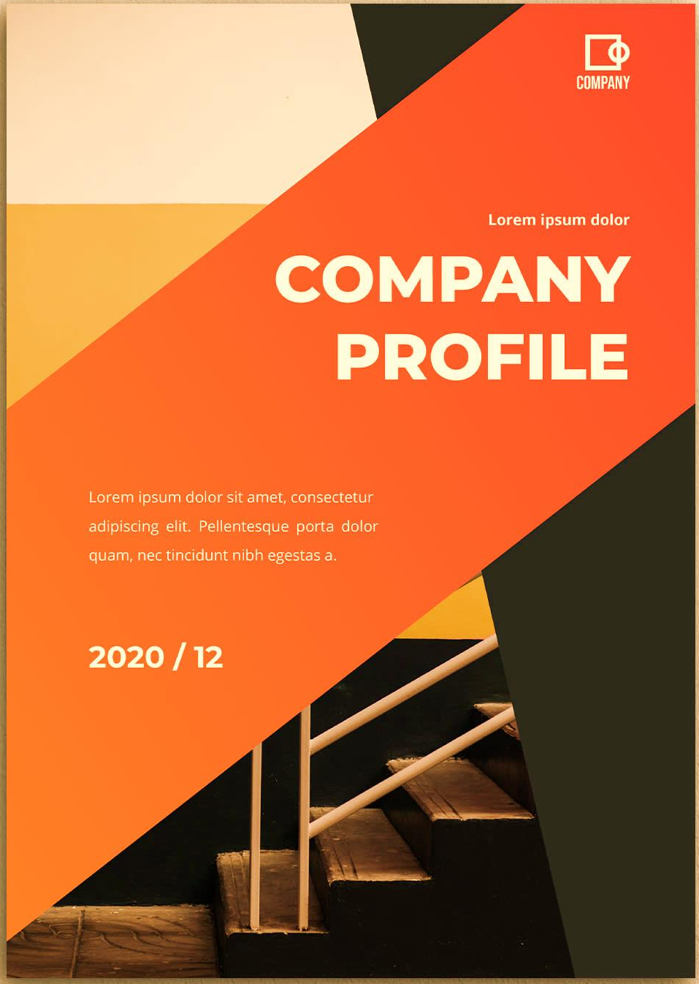


Manab Unnayan Kendra
(MUK)
Organization Profile Update: 2020
Contact address
Amjhupi Bazar, Meherpur-7101, Bangladesh
Tel: 88 0791 62424, 63098 Mobile: 01711397142
E-mail: muk1995@gmail.com
Website: www.muk-f.org

Content table
Content Name | Page no | Content Name | Page no
Acronym | 01 | Staff Member | 11
Executive Summary: | 02 | Staff Strength | 11
MUK in brief | 03 | Current senior staff of the organization | 11
Legal Status of the Organization | 03 | Assets of the Organization | 12
Background | 03 | Vehicle Facilities | 12
Vision Mission Specifically, MUK's role is to: Values of MUK Objectives | 04 | Training Facilities | 13
Organizational Management | 05 | Financial Statement | 14
Working Strategy: | 06 | List of members of the Executive Committee | 15
Geographical Location of the Activities | 07 | Development Project at a Glance (Previous 5 year’s Work Experience) | 16
Target Group Members & Present Beneficiaries | 07 | Present ongoing projects | 17
Network Membership | 08 | Accounting System/Internal Controls | 18
Management Structure | 09 | Self-dependence | 19
Comities of MUK | 10

Abbreviations | Acronyms | Abbreviations | Acronyms
ME | Millennium Enterprise | CC | Climate Change
MP | Meherpur Pouroshava | CCA | Climate Change Adaptation
BR | Birth Registration | CDMP | Comprehensive Disaster Management Program
CBO | Community Based Organization | CSO | Civil Society Organization
CFS | Child Friendly Space | DLAC | District Legal Aid Committee
IDCOL | Infrastructure Development Company Limited | EC | Executive Committee
IOM | International Organization of Migration | ECHO | European Commission's Humanitarian Aid and Civil
MMC | Meherpur Municipal Corporation | PD | Protection department
SDG | Sustainable Development Goal | GoB | Government
NGO | Non-Government Organization | GB | General Body
UK | United Kingdom | IOM | International Organization of Migration
UNDP | United Nation Development Program | BD | Manab Unnayan Kandra
UP | Union Parishad | LEB | Local Elected Body
UPLAC | Union Legal Aid Committee | LGED | Local Government Engineering Department
USAID | United State Agency for International Development | LGI | Local Government Institution
UZLAC | Upazila Legal Aid Committee | LGU | Local Government Unit
VGD | Vulnerable Group Development | MDG | Millennium Development Goal
VGF | Vulnerable Group Feeding | NGO | Non-Government Organization
VSO | Voluntary Services Overseas | SDC | Swiss Agency for Development and Cooperation
WaSH | Water Sanitation and Hygiene | SIDA | Swedish International Development Agency
CDD | Centre for Disable in Development | UDMC | Union Disaster Management Committee
GP | Gangni Pouroshava | UK | United Kingdom
BR | Birth Registration | UNDP | United Nation Development Program
BDT | Bangladesh Taka | UNICEF | United Nations Children's Fund
CBO | Community Based Organization | MUK | Manab Unnayan Kandra
Acronyms

Executive Summary:
MUK has been treating as envisions of the society, which fosters harmonize with the larger community, culture and nature. To make the vision true, MUK works under five different programmatic outcomes as per its strategic plan 2020-2025. Currently our work traces the lives of over 2 million people across Bangladesh, through intervention in five broad development programs including (i) Governance, Democracy, Political Empowerment & Social Accountability,(ii) Peace & Tolerance, (iii) Woman, Children and Disable Rights, (iv) Education Program and (v) Agriculture Development & Income Generating Activities(IGA) mark another successful year of performance.

MUK is transforming public institutions legitimate and effective. MUK try to ensure and promote universal human dignity by practicing of holistic cultural approach. It gradually adds values not just when these remain diverge, but when they actively are engaged in conflict and whether there is proof of strategies that work, in the long term if not in the short term. MUK facilitates to engage community, which belongs multiple people with different intra- religion and cultural back grounds keep their own tradition in a given peace process would take into consideration from the outset which contributes towards a pluralistic approach within community.

MUK’s role is to enhance the agenda for numerous congregations in community to perform as a lens for decision-making around a process as a first step. Through intervening an inclusive process, in depend in gone the context, the main actors like, Religious leaders, Teachers, moreover Students as well youth community is included. Building resilience in peace process it is proven to be beneficial for other reasons, such as making governance mechanisms or institutions more effective and responsive, providing capacity, or addressing the concerns and grievances of constituencies that becomes important bottom of support.

MUK is bringing contextual changes through intervening by popular folk cultural in engaging community are showing ability to resolve existing problem of conflict within the community. Building peace consensus in enabling community to prevent MUK’s program initiatives for respective age groups and professional groups bring engagement to be a willingness to embrace pluralism’s value proposition: that diversity has approached in a positive way with the interests, values and participation of different groups being respected. It needs to mention here that MUK has added some new practices organizationally such as monitoring the development context in formal way collaboration with SCAN/CBR and use the information on programmatic areas, regular assess of check and balance practices within the organization through using monitoring & evaluation tools, trying to practice 'Do no harm' analysis in project planning stage.

For mainstreaming gender in the organization as well as social spheres, MUK's Gender Forum has been functioning independently for the promotion of women rights within the organization with a separate Gender Plan. Anti-Sexual Harassment Cell is active towards an equitable co-relation among men and women within the organization and society.

Section-A: MUK in brief

 | Name of the Organization |  | : | Manab Unnayan Kendra (MUK)
 | Head Office Address with telephone/ Fax/E-mail |  | : | Manab Unnayan Kendra (MUK)  Hat Road, Amjhupi, Meherpur-7101  Tel: 0791-62424, 63098, Mobile: 01711-397142  E-mail: muk1995@gmail.com  Website: www.muk-f.org
 | Contact Person |  | : | Asaduzzaman Selim  Chief Executive
 | Year of Establishment |  | : | 27th August 1995
 | Type of Organization |  | : | Non-government, non-profit and non-political voluntary social development organization
 | Legal Status of the Organization:
 | Date of Registration | Registration number |  |  | Registered institution
 | 27.8.1997 | Kus/223 |  |  | Directorate of Social Service
 | 25.11.2004,  last Renew: 25.11.2019 | FDR/1985 |  |  | NGO Affairs Bureau
 | 28.01.1999 | JUBO/Meher/12 |  |  | Directorate of Youth Development
 | 27.01.2009 | S-8744(765) |  |  | Societies Registration Act xxx 1 of 1860
 | 11/02/2013 | 04615-00668-00686 |  |  | Microcredit Regulatory Authority
 | 2012 continue | BD-2012-AUR-606942937 |  |  | PADOR (European Union)
 | 2017 continue | 731571258 |  |  | D-U-N-S (USA)
 | 2017 continue |  |  |  | SAM
 | 2016 continue | 474025953113 |  |  | TAX/TIN Reg:

7. Background
It was 1995; the Government of Bangladesh and lot of giant and small scaled NGOs were launching various types of development projects in the country to combat all forms of poverty from human lives as well as the country by using million dollars and other resources. Remarkable positive changes were visible especially in the field of education, health, agriculture, communication and transportation, trade and commerce, per-capita income raised beyond expectation. Number of Millionaire increased dreadfully. Life expentory started increasing also. A good number of Politicians, think tankers, business magnets felt proud for this advancement. Within this golden moments, some rural, educated, young man evaluated this situation very critically and they found that the blessings of the country advancement failed to touch the lives of the majority people of rural poor, ethnic minority people, indigenous people and tobacco workers and the women in general violation of human rights were normal and routine work by the power structure and the richest class. Due to partial and unbalanced development mechanism the poor become more poor, exploitation appeared vigorously in our country economy. To combat this injustice, exploitations and inhumanity for establishing a model democratic poverty free society in June 01, 1995 those young people of Hijuli village under the leadership of Asaduzzaman Selim formed a non-profitable, Non-Government organization named MUK, by honoring Bill of Human Rights. All neglected children, women, youth, ethnic, indigenous people, tobacco workers and dalit community, Victims Of Human Trafficking, socially vulnerable people will get development services from this organization and to work legally in this country MUK got registration from the Department of social welfare, Meherpur on 27.08.1997.

8. Vision
Equity based democratic, poverty free, enhances the productivity of agriculture, sustainable society, which respect to human rights, mainstreams gender equality, and ensures social justice through good governance and sustainable development.

9. Mission
To achieve the rights of marginalized, disadvantaged, & vulnerable people particularly women and children from across the society by establishing democratic principles, rule of law and gender justice through good governance and to enhance the productivity of agriculture and animal husbandry.

10. Specifically, MUK's role is to:
1. Establish democracy and governance through people's participation
2. Promote the rights of children, youth, women the differently able and marginalized people.
3. Resuscitate, develop and foster folk cultural forms and methods to sensitize grassroots people.
4. Build peoples' capacity to cope with the impacts of climate change and natural/manmade disaster and to conserve natural bio-diversity.
5. Build resilient strategic planning for agriculture through community intervention.

10. Values of MUK
The people of MUK have agreed on a set of values as guiding principles to establish a favorable internal environment and thus contribute to the defined mission.

The staff members will practice mutual respect at work place and the organization will evaluate on its staff members' performance. Participatory decision making will be continuous process. Free sharing of experience, view and information will create a sound basis for the organizational decisions. Cooperation rather than destructive competition will govern inters personal behavior. The rules and regulations will apply equally for all. MUK will encourage self-initiative based sense of responsibility. The Team Leader will maintain the proper chain of command. Discipline and attitude of a development worker will guide the individual behavior at work place. Self-criticism and honesty will be the cornerstones of staffs as well. All staff members will use the resources economically and set for sustainable development of the institution. The staff members will consider the organizational issues as strictly internal. They will remain conscious of gender sensitive behavior both at work place and outside.

11. Objectives:
- To improve livelihood and socio-economic status of the underprivileged people of Meherpur district.
- To ensure 100% education for all
- To make skilled and self- reliance the unemployed youth by providing vocational support.
- To make empowered the persons with disability in the field of human rights and to help them in need.
- To make strengthen and accountable Union parishads by activating Governmental machineries.
- To create justice in village level.
- To establish a child and women-friendly Society.
- To ensure equitable price of the Agricultural products supply and poison-free fruits.
- To encourage people for using safe and pure drinking water
- To extend Technical and financial support in any emergency.
- To ensure citizen rights of the Minority people.
- To maintain ecological balance.
- To contribute the Nation for achieving SDGS and
- To make Meherpur district Free from Human Trafficking.
- Increase agricultural production to raise farmer’s income.
- Ensure proper health, nutrition and hygiene status.
- Ensure quality education to all students.
- Create greater unity of the beneficiaries to protect any violence against them and to ensure justice.
12. Organizational Management
a. Governance
MUK is governed by two-tier governing bodies comprising of general Body (GB) with 31 members and Executive Committee (EC) with 7 members. The day-to–day management of the organization is conducted by a senior management team lead by Chief Executives.

b. Human Resource Management
The human resource ensures MUK's team has the capacity, commitment and professionalism necessary to meet the challenges of implementing MUK's latest2020-2025 strategic plans. In 19-20 periods, 65 paid Staffs (about 40% of them are Women) have worked in the Organization and 75 Volunteers that are dedicated to implement various activities aimed at achieving the goal of human development in Bangladesh.

c. Financial Management
Financial capacity of the Organization: MUK has been handling funds for more than 25 years and in course of time has gained sufficient level of experience in handling project funds. At present MUK operates 27 bank accounts with different bank for smooth operation of all projects with separate accounts for each project and departments. MUK financial management system maintains national and international standards and policies for best use of resources and technological control. Activities that are carried out under financial management are:
d. Audit System and Reporting
MUK has two auditing system, an internal and external. The internal audit is conducted by two internal auditors. They directly report to the executive directors. The auditors make field visit and prepare quarterly audit report for each and every project. The external audit is conducted by MUK's audit committee headed by the executive director and approved by executive committee. MUK has enlistment of audit firms who are the top ten firms of the country and are affiliated internationally and to NGO affairs bureau.

e. Resources and Others Facilities Available To Support the Program
MUK is able to support its most implemented program through its resources, assets, human resources, skills and technical equipment. MUK has individual related following department with related professional skilled staff,

- MUK Administration Department
- MUK Training Unit
- MUK Finance Department
- MUK Logistic department
- MUK Monitoring and Evaluation Department
- MUK Development program Department
- MUK Audio Visual & IT department.
- MUK School Unit
Aforementioned departments have skilled staff with different job responsibility as per organizational need. The departments have also developed its policy, which is dully approved by the management. The departments are also capable to perform their job as per policy independently.
14. Working Strategy:
A. MUK has already developed a community based development approach which enabled opportunities to accept to informal justice systems formal education for grassroots children, income generating program for hardcore poor women. The organization has adopted the strategy to bring in power to the community people and local stakeholders. Including alternative representation at local government, community and religious leaders. The organization has already upheld various committees at community level, which is the steps towards sustainability contributing achieving SDG goals 1,2,3,4,5,6,8,13,15 and 16. Developments for example the organization has brought positive and effective changes in the state sponsored services of the poorest though social audit and introduction of citizen charters.
In achieving the above objectives, MUK has clearly formulated certain strategies & principles that are operationalized through some programs.

- Planning through community initiatives and implementation effectively.
- Joint adventure with local community and organizations in risky areas.
- Local and National level networking and policy advocacy.
- Organized the leaders of the civil society through various platform for participatory action.
- Ensuring local contribution in works.
- Preparing implementation strategies with MUK top and mid-level management and facing challenges.
- Arrangement of internal audit for quality performance.
- Human resource development;
- Structural poverty alleviation through enhancing organizational and human capacities in agriculture and food and nutrition security.
- Improvement of gender equality;
- Participatory development research;
- Established SDG.

B. Focus/Core Themes:

MUK has focused on the following core thematic areas:
- Sensitizing local justice delivery system towards the needs of women.
- Ensuing transparency, accountability of the service delivery institutions and social safety net.
- Bringing all children form grassroots level causes formal education system.
- Enhance opportunities for farmers (both man and women), predominantly small and marginal into income generating activities through enhancing the productivity of agriculture (crops, livestock and fisheries).
- Sustainability in all steps of development initiatives.
- Mass people centered development initiative.
- Poverty alleviation by local management, local resources and local ideas/indigenous knowledge.
- People can explore the way of develop make success any project as a group/team.

15. Geographical Location of the Activities
MUK is a modern style, efficient and highly client oriented non-government organization. The organization is working both in urban and rural areas. MUK has been working in 258 villages under 7 Upazilas of 3 districts in Bangladesh. The information of the operational district of the organization are given below:

Sl. No. | District | Upazila | Union | No. of Village
 | Meherpur | Sadar | 05 | 65
 | Meherpur | Gangni | 06 | 52
 | Meherpur | Mujibnagar | 04 | 38
 | Chuadunga | Sadar | 09 | 27
 | Chuadunga | Alamdunga | 05 | 28
 | Kushtia | Daulatpur | 08 | 23
 | Kushtia | Mirpur | 04 | 25
 | 3 | 7 | 48 | 258

16. Target Group Members & Present Beneficiaries:
A. Target Group Member:
The target beneficiaries of MUK are the poor oppressed and the disadvantaged in the society constituting the bulk of the population i.e. the destitute women and children, the landless, small and marginal farmer persons with disability, migrant labour, ethnic minority communities, indigenous people and tobacco workers, drug addicted persons, sex-workers, ageing people and the other occupational groups who are victims of hunger, malnutrition and social injustice. The organization works with 30,000 beneficiaries, which is also the strength of the organization.

B. Present Beneficiaries:

Sl no. | Type of Beneficiaries | Direct Beneficiary | Indirect beneficiary | Total
1 | Child | 3675 | 12,475
2 | Adolescent | 2350 | 7,250
3 | Female | 17,285 | 52,350
4 | Male | 4,075 | 20,500
5 | Disable | 230 | 775
6 | Senior Citizen | 350 | 1,277
Total |  | 27,965 | 94,607
17. Network Membership:

SL | Name of Network | Type of Network | MUK Status | Year
01 | HelpAge Global Network | International | Member | 2016
02 | Frame work International | International | Member | 2009
03 | Global Human Rights Defense (GHRD) | International | Member | 2011
04 | Governance Coalition (GC) | National | Member | 2003
05 | Campaign for Popular Education (CAMPE) | National | Affiliate Member | 2006
06 | Bangladesh Shishu Adhikar Forum (BSAF) | National | Member | 2003
07 | National Forum of Organizations Working with the Disabled (NFOWD) | National | Member | 2007
08 | Association for Land Refund Development (ALRD) | National | Member | 2002
09 | Jatio Nari Nirjaton Protirodh Forum (JNNPF) | National | Member | 2009
10 | NGO Forum for Public Health | National | Member | 2002
11 | STI/(HIV) AIDS Network of Bangladesh | National | Member | 2007
12 | Civil Society Alliance (CSA/SUN) | National | Member | 2008
13 | Gender and Water Alliance (GWA) | National | Member | 2011
14 | Credit and Development Forum (CDF) | National | Member | 2003
15 | Amar Odhikar Forum (AOF) | National | Member | 2003
16 | Bangladesh Labour Welfare Foundation (BLF) | National | Member | 2013
17 | National Human Rights Commission | National | Member | 2013
18 | Sustainable Agriculture Network | Regional | Member | 2009
19 | Justice Makers Bangladesh | Regional | Member | 2010
20 | Child Safety Network | Regional | Member | 2010
21 | ADAB | Regional | Member | 2000
22 | Meherpur NGO Shamiti | Local | Member | 2012
23 | Meherpur Development Forum | Local | Member  Secretary | 2005
18. Management Structure:
MUK has developed and organized a structured management system, which is not bureaucratic. The organogram shows the relations and accountability both vertically and horizontally.


General Body

Executive Committee
Advisory Committee

Chief Executive

Management Committee (Senior Staff)
Project/Program Coordinator
Senior Program Manager
Program Manager
Deputy Program Manager
Asst. Program Manager
Senior Program Officer
Field/Program Officer
Asst. Program Officer
Senior Program Organizer/ Program Assistant
Asst. Program Organizer
Monitoring Officer
Accounts Officer
Asst. Finance Officer
Logistic/Store keeper/Office Assistant
Peon/Support Staff/Driver
Security Guard/Night Guard
Principal
Teacher
Peon/Support Staff/Driver
Security Guard/Night Guard
Students/Beneficiaries
Finance Manager
Asst. Admin Officer
Communication Officer
Senior Teacher
Program Organizer
Operator
19. Comities of MUK:
General Committee:
General Committee is the highest body of MUK and consists with 23 members. The Committee meets twice a year. But if necessary, it can summon emergency meeting. The member of the General Committee will pay regular monthly subscription, actively take part in each meeting of General Committee and different social work. The General Committee will form the Executive Committee, Advisory Committee and will approved annual budget.

Advisory Committee
Advisory Committee consists of 5 members. The committee formed with intelligent, social worker and honorable persons. The responsibility of the Advisory Committee is to advice General Committee and Executive Committee, to provide proper guideline to the General Committee and Executive Committee and to assist Chief Executive in his/her work.

Executive Committee (EC)
The members of the General Body elect 7-member Executive Committee for the period of 3 years. The EC sits once in a quarter to look after the activities of the organization and takes necessary decisions. The Committee is responsible for overall management of total program/project implemented by the organization. The responsibility of the Committee is to create income sources and maintain accounts, budget preparation, bank account operation, participate in bi-monthly and special meeting, deposit and fixed assets and liquid assets.

Chief Executive
The Chief Executive is appointed by the Executive Committee. She/he is the executive head of the organization. Chief Executive will implement all decisions of the Executive Committee. She/he is responsible for overall administration and program implementation. To discharge her duties, he/she is assisted by her sub-ordinate staff. She/he is responsible for keeping contact with the government and non-government agencies and donors. The Chief Executive is accountable to the Executive Committee.

Higher Level Management Staff Team/Committee:
To ensure transparency, accountability, mobility of works and for proper planning a 9-member senior level staff management committee is form for 2 years with senior level and mid-level staffs. This committee sit for meeting fortnightly and monthly basis. MUK CEO moderate these meetings. As per need and importance recommendations and decisions of these meetings submitted to the MUK Executive Committee for final approval. After approval of the EC, their decision introduces in the field. Higher Level Management Staff Committee informed according to the will of the CEO and responsible to ensure transparency and accountability of the program.

Mid-Level Management Staff Committee:
To organize the program, to face risen all challenges to fulfill objective of the program, to help to prepare new development plan are the functions of Mid-Level Management Staff Committee. The committee sit for meeting to take necessary program related decisions in fortnightly and monthly meeting chaired by CEO/Coordinator of MUK. This committee consist on 13 members for 2 years and among them 2/3 persons are from higher management committee and the rest from all level of staffs.

19. Staff Member
MUK has a good number of staff (full time and part time) and volunteers. There is central office staff and project staff. The project staffs are responsible for the proper implementation of all field activities. The staffs of the central office are responsible to the Chief Executive and the area/project office staff are responsible to the respective Program Coordinators, Program Manager through Area Coordinator. The Program Coordinators are accountable to the Director (Program). The Area Coordinators are also responsible to the Chief Executive. Beside this, the field organizer, supervisors, accountants and Admin Officer report to the program Coordinator.

20. Staff Strength

Level | Sex |  |  | Placement
Level | Male | Female | Total | Office based | Field based
Management | 07 | 04 | 11 | 02 | 09
Mid-Level | 06 | 03 | 09 | 03 | 06
Field Level | 17 | 11 | 28 | 02 | 28
Volunteer | 05 | 02 | 07 | 02 | 05
Total | 35 | 20 | 55 | 09 | 46

21. Current senior staff of the organization

Designation | Sex | Duration in the Present job (years) | Remarks
Chief Executive | M | 22 | Founder Chief  Executive
Program Coordinator | M | 03 | -
Monitoring/Audit Officer | M | 04 | -
Finance/Admin Manager | F | 22 | Founder Staff
Administration Officer | M | 02 | -
Program Manager | F | 13 | Founder Staff
Program Manager | M | 24 | Founder Staff
Program Manager | M | 20 | Founder Staff
Program Manager | F | 14 | -
Program Manager | F | 17 | -
Program Manager | M | 08 | -
Program Manager | M | 07 | -
Program Manager | M | 02 | -
Asst. Program Manager | M | 03 | -
Asst. Program Manager | M | 03 | -
Finance Manager | M | 04 | -
District/Upazila Coordinator | F | 06 | -
22. Assets of the Organization:
- Assets/properties:

Sl. No. | Particulars | Total Number | Condition
Sl. No. | Particulars | Total Number | Good | Average
 | Computers | 20 | 17 | 3
 | Laptop | 07 | 03 | -
 | Printer | 06 | 05 | 1
 | Scanner | 02 | 02 | -
 | Telephone (Land) | 02 | 02 | -
 | Mobile | 25 | 15 | 10
 | Television | 07 | 05 | 02
 | OHP | 01 | 01 | -
 | Steel Almira | 09 | 05 | 04
 | Wooden Almira | 15 | 11 | 05
 | File Cabinet | 24 | 14 | 10
 | Book Self | 17 | 10 | 7
 | Sealing Fan | 75 | 55 | 20
 | Rack | 28 | 20 | 08
 | Armed Chair | 45 | 45 | 20
 | Ordinary Chair | 150 | 110 | 40
 | Full Secretary Table | 25 | 20 | 05
 | Half Secretary Table | 30 | 20 | 10
 | Meeting Table | 10 | 10 | -
 | VIDEO Camera | 01 | 01 | 00
 | Digital Camera | 03 | 02 | 01
 | Generator | 02 | 01 | 01
 | DVD player | 02 | 02 | -
 | Sofa set | 15 | 13 | 02

23. Vehicle Facilities:

Sl. No. | Type of Vehicle | No. Available |  |  | Remarks
Sl. No. | Type of Vehicle | Own | Rented | Total | Remarks
 | Auto Rickshaw | 01 | - | 01
 | Motor Cycle | 03 | 15 | 18
 | Bi-Cycle | 05 | - | 05
24. Training Facilities:
a. Training Center-1
Sl # | Name and Address of Training Centers |  | Year of Establishment |  |  | Comments
 | MUK, Amjhupi, Meherpur |  | June, 1998 |  |  | Own & well organized
Facilities |  | Capacity |  | Own/Hired | Quantity / No. |  | Remarks
Training Room |  | 40 persons |  | Own | 1
Dormitory with accommodation (Bed etc.) |  | 40 persons |  | Own | 2
Feeding facilities |  | 40 persons |  | Own | -
Training Equipment
a. Chair |  |  |  | Own | 40
b. Training Table |  |  |  | Own | 40
c. Color TV |  |  |  | Own | 1
d. VCP |  |  |  | Own | 1
e. Flip Board |  |  |  | Own | 4
f. White Board |  |  |  | Own | 4
g. Fan |  |  |  | Own | 8
VIPP Board |  |  |  | Own | 5
Music set |  |  |  | Own | 2

b. Vocational Training center
Facilities | Capacity | Own/Hired | Quantity /No. | Remarks
Training Room | 35 persons | Own | 1
Dormitory with accommodation (Bed etc.) | 30 person | Own | 6
Fooding facilities | 30 person | Own | --
Training Equipment
Sewing machine |  | ,, | 10
Refrigerator for practice |  | ,, | 4 sets
Airconditioner |  |  | 4 sets
a. Chair |  | Own | 35
b. Training Table |  | Own | 15
c. Color TV |  | Own | 1
d. VCP |  | Own | 1
e. Flip Board |  | Own | 2
f. White Board |  | Own | 2
g. Fan |  | Own | 8
VIPP Board |  | Own | 5
Musical Instrument |  | Own | 2
25. Financial Statement:
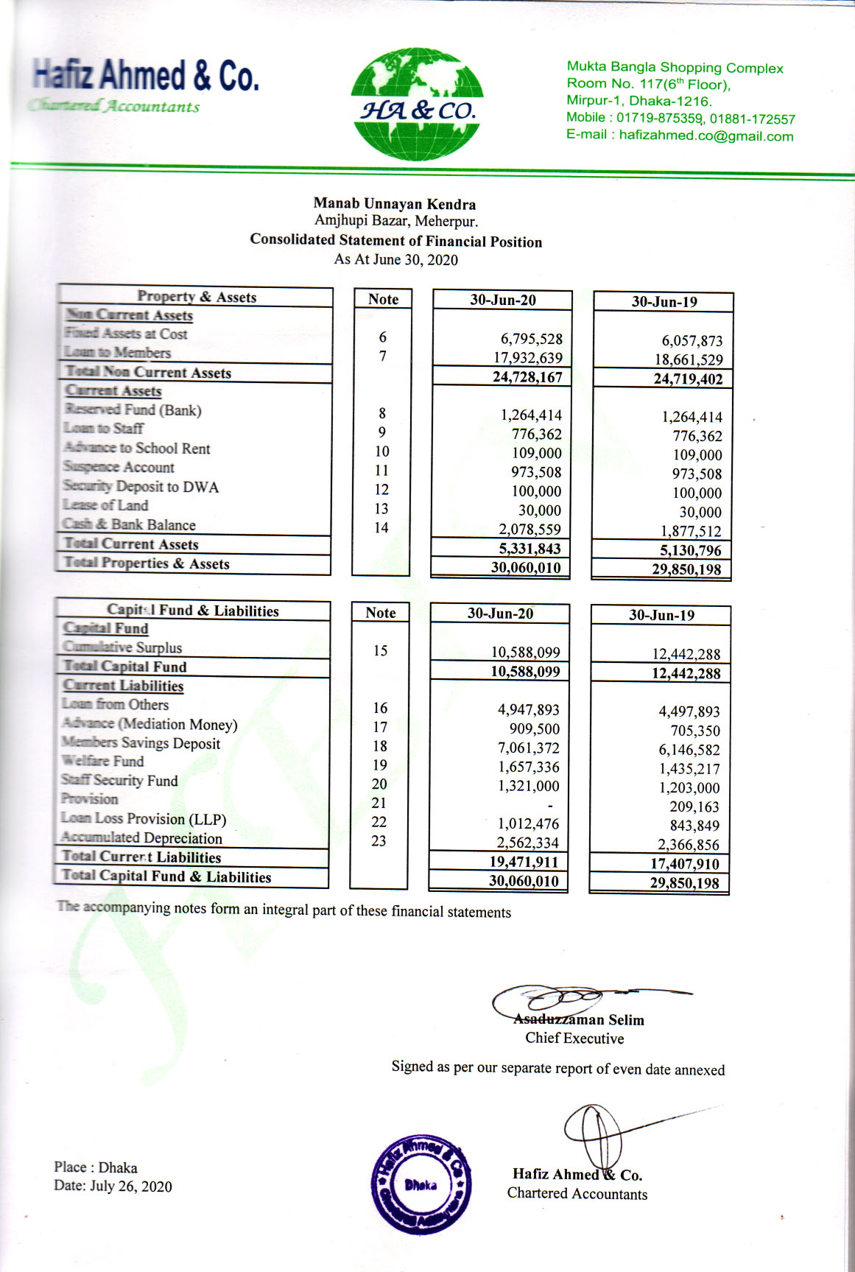

The accompanying notes from an integral part of these financial statements.

26. List of members of the Executive Committee
Executive office
The Executive Office is headed by the Chief Executive who executes projects and programs with the support of a number of dedicated and motivated staffs, workers and the professionals. The head office is located at Amjhupi Town and field offices are located in the working areas.

SL | Name | Sex | Profession | Duration of involvement  (years) | Portfolio
01 | Md. Saiful Islam | M | Social Worker | 03 | President
02 | Rasidul Islam | M | Teacher | 07 | Vice. President
03 | Asaduzzaman Selim | M | Development Worker | 25 | Chief Executive
04 | Azimul Haq Lavlu | M | Social Worker | 03 | Joint Secretary
05 | Md. Moazzem Hossen | M | Business | 06 | Treasurer
06 | Lotifon Nesa (Lota) | F | Social Worker | 06 | Member
07 | Samsun Naher (Lipi) | F | Teacher | 02 | Member

Section-B: Programs
27. Development Project at a Glance (Previous 5 year’s Work Experience):

Ongoing Project : Title of project undertaken | Name of donor/Development Partner | Name of project Upazila/ district | Types of specialized activities undertaken in the project
Non-formal Education for child labour | Winrock International | Meherpur Sadar | Conducting practicing centre for children centre for children,-Running children club
Protecting Victims of Human Trafficking in Bangladesh | Relief International | Meherpur Sadar | Mass Awareness Raising  Training on life and livelihood skill development  Providing psychological  legal counseling  Encouraging to establish entrepreneurial project  Legal aid support  Encouraging the victim to form their association
Trinomul Model Academy (Formal Education up to grade five, two schools) | Muk general fund and GOB | Meherpur Sadar | Conducting joyful model learning Model of ensuring community
Action Research on quality primary education for finding out strategy towards achieving national MDG goals | CAMPE & DFID | Meherpur Sadar and Mujibnagar | Community mobilization monitoring,  -A awareness raising
Advocacy with local government and good governance and Food for All Rights Program | Danida Fund & Governance Coalition | Meherpur Sadar | Strengthening local government –  Advocacy at grass roots level for ensuring access to government services
Ensuring the use of eco-friendly and sustainable modern cooking wood stove | USAID | Meherpur Sadar  Upazilla | -Advertisement, milking, fair, workshop, school sessions, demonstration and selling of stoves
Enhancing Opportunity to Justice at rural Level | Madaripur Legal Aid Association (MLAA | Mujibnagar &  Meherpur sadar | -Village court, Mediation, Courtyard Meeting
WATSAN- Ensuring pure drinking water supply and sanitation at community level under NGOFC | NGO Forum | Meherpur sadar  &  Gangni upazila of Meherpur District | Popular theatre, Courtyard meeting, Students orientation, Quiz competition, Rally, Teachers orientation of UP members, Folk songs, Orientation of religious leaders, Mosque based discussion
Group formation and micro credit support | Muk and BRAC | Meherpur sadar | -group formation Capital support
Child & Woman rights Advocacy Program | UCEP Bangladesh | Meherpur district | Organizing groups for the protection of family violence, especially for the creation of universal human rights for women and children, training, counseling, day keeping and advocacy with service organizations.
Vulnerable Group Development program [VGD] | Directorate of Women Affairs Bureau | Jhenidah and Meherspur District | Encourage on savings, Training of income generating, Awareness on health and nutrition including violence against women and trafficking.
Prevention of child trafficking and early marriage | Bangladesh Shishu Adhikar Forum [BSAF]  Technical support | Meherpur district | Awareness about trafficking involving local community & religious leaders. Lesson and contribute to district anti trafficking committee
28. Present ongoing projects:
SLNo | Name of Donor | Project Title | Nature of Support
1 | Center for Disability in Development (CDD) and Colour Style Bangladesh Ltd. | Treatment and rehabilitation of the person with disabilities & Disable and autism School | Financial | Technical
2 | Bangladesh NGO Foundation (BNF) | Initiative to create privilege to offer services to the neglected ageing people | Financial | Technical
3 | JNNPF and Action Aid Bangladesh | Child and women rights advocacy | Financial | Technical
4 | Bangladesh women health coalition & Ministry of Health and Family Planning | Premiere health core and nutrition protect | Financial | Technical
5 | IDCOL-Dhaka/USAID | ICS/Eco-friendly Improved Cook Oven Installation | Financial | Technical
6 | CAMPE & PKSF | Quality Education for All  (RACE project) | Financial | Technical
7 | Relief International (RI) | Technical support to the Trafficked victims | Financial | Technical
8 | Bangladesh Women Affairs Bureau. | Training support for the Antenatal mothers &VGF Card holders. | Financial | Technical
9 | Drink-well International& NGO Forum for Public Health | WATSAN/Arsenic Mitigation Project | Financial | Technical
10 | HRDC/ALRD-Dhaka/Misereor | Marginalized indigenous women & Child rights &People’s Cooperative Project | Financial | Technical
11 | Rupantar/Decmocracy International | Win with peace | Financial | Technical
12 | Muk Sponsored | Micro Credit for socio-economic development program | Financial | Technical
13 | Muk Sponsored | Local Arbitration and Legal Aid Support program | Financial | Technical
14 | Muk Sponsored | Formal Education activities | Financial | Technical
15 | Muk Sponsored & personal grants of local people | Covid-19 epidemiological health and food security development project | Financial support and food distribution | Health awareness
Section-C

29. Accounting System/Internal Controls

- Normal method of disbursing payments: Account payee cheque against a payment above ten thousand takas.
- Organizational recording process: Manual Ledger System
- Types of ledger in practice: Main ledger and subsidiary ledger
- Transaction procedure: Transactions are made through request forms, purchase orders, vouchers etc. Chief Executive is the approval authority.
- Accounting system about multiple projects: Have the capacity to track multiple projects.
- Capacity of accounting system: MUK has the capacity to track individual person, project expenses against budget line item categories.
- Accounting policy: Organization have a written accounting policies and procurement policies. This includes an independent committee for purchase above ten thousand takas.
- Organization’s record retention policy for financial data: All data is checked by the account officer, Chief accounts officer, Chief Executive. Cheque is placed before the general members in the Annual General Meeting (AGM) and is approved by the general members.
- Bases of reports issued: Cash basis
- Time of financial reports prepared: Weekly, Monthly, Quarterly and Annually.
- Bank account reconciliation: Bank account reconciliation prepared on monthly basis
- Petty cash account: Organization maintains a petty cash account worth Five thousand.
- Frequency of financial Audit: Accounts are audited on an annual basis by the Chartered Accountant Firm enlisted by the NGO Affairs Bureau.
- Internal auditing system: Organization has an internal auditor on standby.
- Organizational Policy: Organization has a written Micro-Finance policy, Service Rule, Gender policy and
- Vat/taxation: The organization follows the government's rule of VAT and taxation very strictly.
- Value for money: The organization implemented those projects or activities that have value for money.

30. Self-dependence

Labour Force:

Manab Unnayan Kendra – MUK has already developed a skilled Labor force of its own by imparting skill building training to its program beneficiaries of execution areas. This Labor force takes parts in field level implementation of various programs/project and utilize respective skills.

Experience in Financial Micro-credit:
Manab Unnayan Kendra- MUK has experience of 19 years in financing micro-credit. Manab Unnayan Kendra- MUK established 1995, but since its inception this organization has been providing rural poor with credit support setting the goal to alleviate poverty target groups by promoting their financial self-reliance.

Linkage with Banks:
Manab Unnayan Kendra- MUK has Linkage with Dutch Bangla Bank as their Super Agent in Meherpur District.

Management

Quality of Management standard:
Manab Unnayan Kendra- MUK has been operating under a standard management system that includes 3 ties of accountability, namely, General Committee, Executive Committee and Advisory Committee. All committee members and staff members are academically qualified, committed, disciplined and squarely experienced in MFI management.

Second Line/Succession:
MUK has different section senior representatives which made a managing Committee. This Committee co-operates program coordinator and same permanent posted staff. This Management Committee is reliable to make Organizations Policy, written works and field project.

Liaison:
Manab Unnayan Kendra- MUK maintains liaison with rural range of agencies including Government, NGO, Corporations, development networks, MFIs, Banks, community organizations and grant-making agencies both in home and abroad.

Security Arrangement
Personal guarantee with land mortgage of the members of the Executive Committee. Postdated cheque as per repayment schedule. 01 (one) undated cheque covering the entire loan amount along with authority to insert date on the cheque. Financial Security: 10% FDR of sanction loan amount. Usual charged document. Loan Agreement between MFI Bank.

Yours Faithfully,

Assaduzzaman Selim
Chief Executive
Manab Unnayan Kendra- MUK
Date:

